 ** **

**Mathematics Specialist  
YEAR 12**

**Investigation 2 – Filing a Vase**

**Semester 2 2019**

**In-Class Assessment**

**Time allowed:** 50 minutes

**Marks Available:** 33 marks

**Materials required:** Writing implements, correction fluid/tape or eraser, ruler, Scientific or CAS calculator, one double sided unfolded A4 page of notes.

**Instructions:**

1. Write your answers in the spaces provided in this Question/Answer Booklet.
2. **Show all your working clearly in preparation for the Validation Test**. Your working should be in sufficient detail to allow your answers to be checked readily and for marks to be awarded for reasoning. Incorrect answers given without supporting reasoning cannot be allocated any marks. For any question or part question worth more than two marks, valid working or justification is required to receive full marks. If you repeat an answer to any question, ensure that you cancel the answer you do not wish to have marked.

A liquid flows into an irregular shaped vase at a constant rate. How does the height of the liquid change with time?

1. [7 marks]  
   The vase pictured is being filled at a **constant rate** to a depth of 20 cm (as shown), which takes 90 seconds. The table below shows the time taken in seconds to reach a given height in centimetres on the vase. Draw a graph of the height of the liquid compared to time. Relate key features of the graph to the shape of the vase.

|  |  |  |  |  |  |  |  |  |  |  |  |
| --- | --- | --- | --- | --- | --- | --- | --- | --- | --- | --- | --- |
| **t** | 0 | 4 | 8 | 13 | 20 | 27 | 37 | 45 | 52 | 60 | 68 |
| **h** | 0 | 1 | 2 | 3 | 4 | 5 | 6 | 7 | 8 | 9 | 10 |

|  |  |  |  |  |  |  |  |  |  |  |
| --- | --- | --- | --- | --- | --- | --- | --- | --- | --- | --- |
| **t** | 72 | 76 | 79 | 81 | 82 | 83 | 84.2 | 85.6 | 87.4 | 90 |
| **h** | 11 | 12 | 13 | 14 | 15 | 16 | 17 | 18 | 19 | 20 |

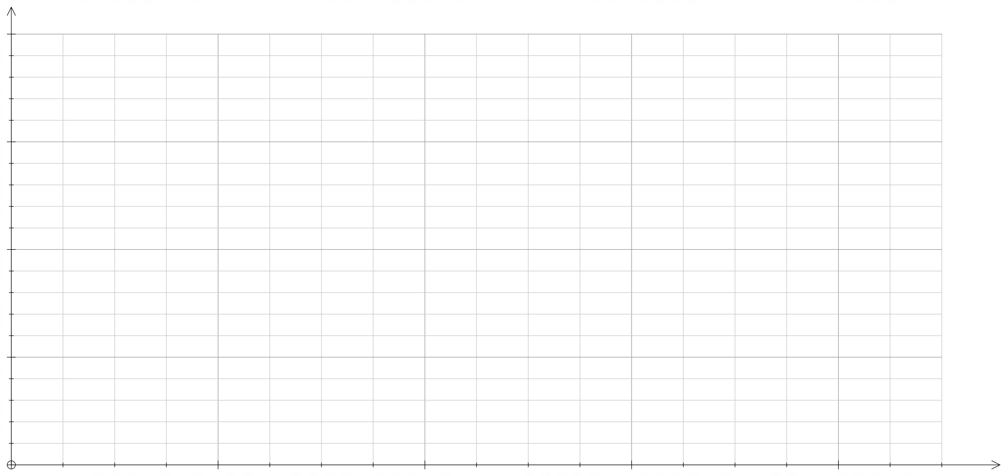

1. [4 marks]  
   Choose an appropriate function to model the positive cross-section of the vase, given it is known the vase passes through points P, Q, R and S. Determine the equation for this function, coefficients should be accurate to 4 s.f.

1. [3 marks]  
   The actual volume of the vase is 1 litre when filled to a depth of 20cm, the amount shown in the original picture. Prove that this is correct and explain why there may be a small amount of error in your solution.
2. [13 marks]  
   Determine the rate of change of the height of the liquid, h, with respect to time, t, using related rates and hence determine where the rate of change of the height of the liquid, h, with respect to time, t is increasing at a maximum rate.

Note: The rate can be in terms of the height of the liquid h. Discuss your solution in terms of the shape of the vase.

1. [6 marks]  
   Determine a function relating the height of the liquid in the vase to time and define this rule as *t(h).* Discuss how well this function models the data.

**End of Investigation**